International Coaching Clinic
Pentecost weekend
Program:

Saturday, the 22nd of May

Coach: Arik Shivek

Topic: 1) Moving without the basketball
(from basic to game situations)

2) PnR Defense

Sessions: 10h00-11h30 and 14h00-15h30

Venue: Hall Omnisports Mersch

Sunday, the 23nd of May

Coach: Arik Shivek

Topic: low post offense with strong / weak side actions

Session: 9h15-10h45

Venue: Hall Omnisports Mersch

International Coaching Clinic
Pentecost weekend
Program:

Sunday, the 23nd of May

Coach: Thomas Päch

Topics: 1) Individual practice

2) Decision making and reads in transition offense situations

Sessions: 11h00-12h30 and 14h00-16h00

Venue: Hall Omnisports Mersch

International Coaching Clinic
Pentecost weekend
Program:

Monday, the 24nd of May

Coach Kris Van Der Haegen

Topic: Child Centered Coaching

Session: 9h00-11h00

Venue: Coque Amphitheatre (tbc) (*)

Tuesday, the 25nd of May

Coach: Pierre Cornia

Topics: 1) Built up of a motion offense from U14 to senior level

2) Built up of a switching defense concept on ball screens, from U14 to senior level

Sessions: 9h00-12h00 and 13h00-14h30

Venue: Hall Omnisports Mersch

International Coaching Clinic
Pentecost weekend
Program:

Hall Omnisports Mersch:

Rue des Prés L-7561 Mersch

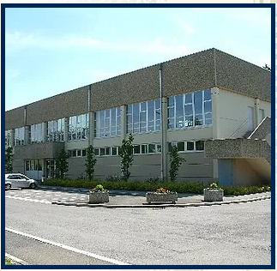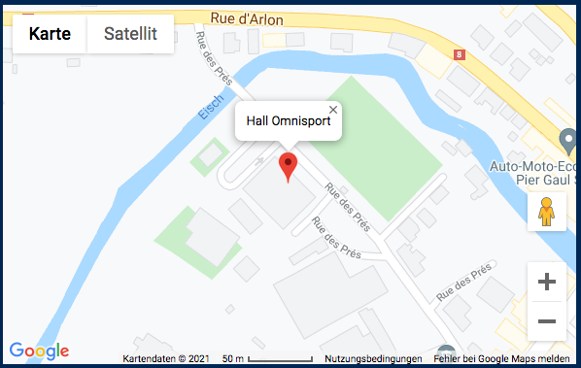

Coque Sport Center (d'Coque Centre National Sportif & Culturel)

2 Rue Léon Hengen, 1745 Luxembourg

